Physics
Physics is the study of Energy.
Energy is the ability to do work
Work is when a force moves something.
How We Measure Energy and Work
We measure things using units of measure
Examples
Quantity | Unit of measure
Temperature | ºC
Speed
Length
Energy | J(joules)
Work | J(joules)

1000 joules=1kj
The energy stored in food is shown in KJ. Here is the wrapper on a bottle of coke.
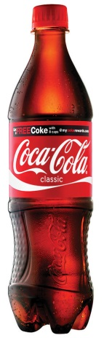

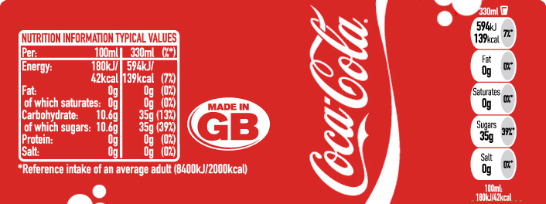
How much energy is there in this bottle of Coke?

